Class Diagram - Case Studies

Case 1

Students may attend any number of courses.
Every course may have any number of students.

Instructors teach courses.
For every course there is at least one instructor.
Every instructor may teach zero or more courses.

A school has zero or more students.
Each student may be a registered member of one or more schools.

A school has one or more departments.
Each department belongs to exactly one school.

Every instructor is assigned to one or more departments.
Each department has one or more instructors.

For every department there is exactly one instructor acting as the department chair.
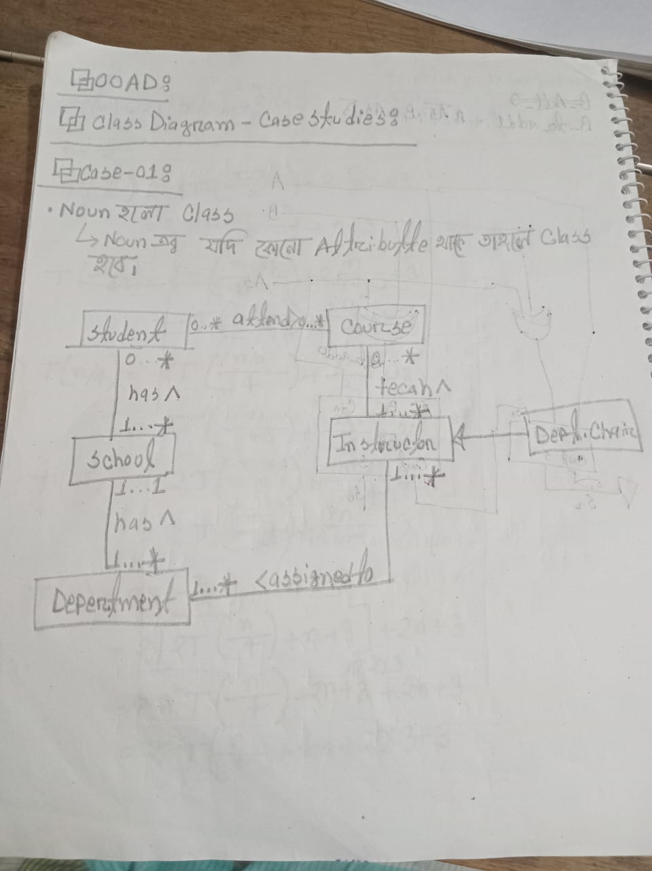

Case 2

A building is owned by one person. A person may own more than one building. Each building is either a house or an apartment. An apartment contains two or more Rental Units. A person can buy a house and rent or vacate a Rental Unit.
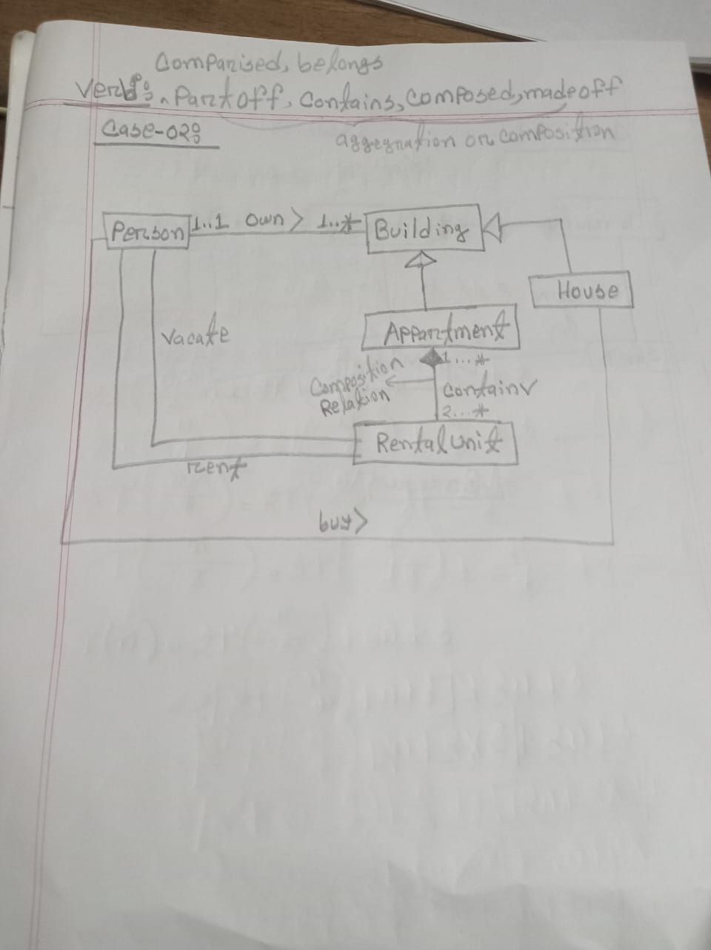

Case 3

A company has one or more divisions. A division has one or more departments. A department can have one or more employees assigned to it. An employee is assigned to one department. Employees can be either supervisor or officer. Each division is made of at least one supervisor. A supervisor can be a part of one or more division. Each department consists of at least 3 officers. An officer is a part of exactly one department.
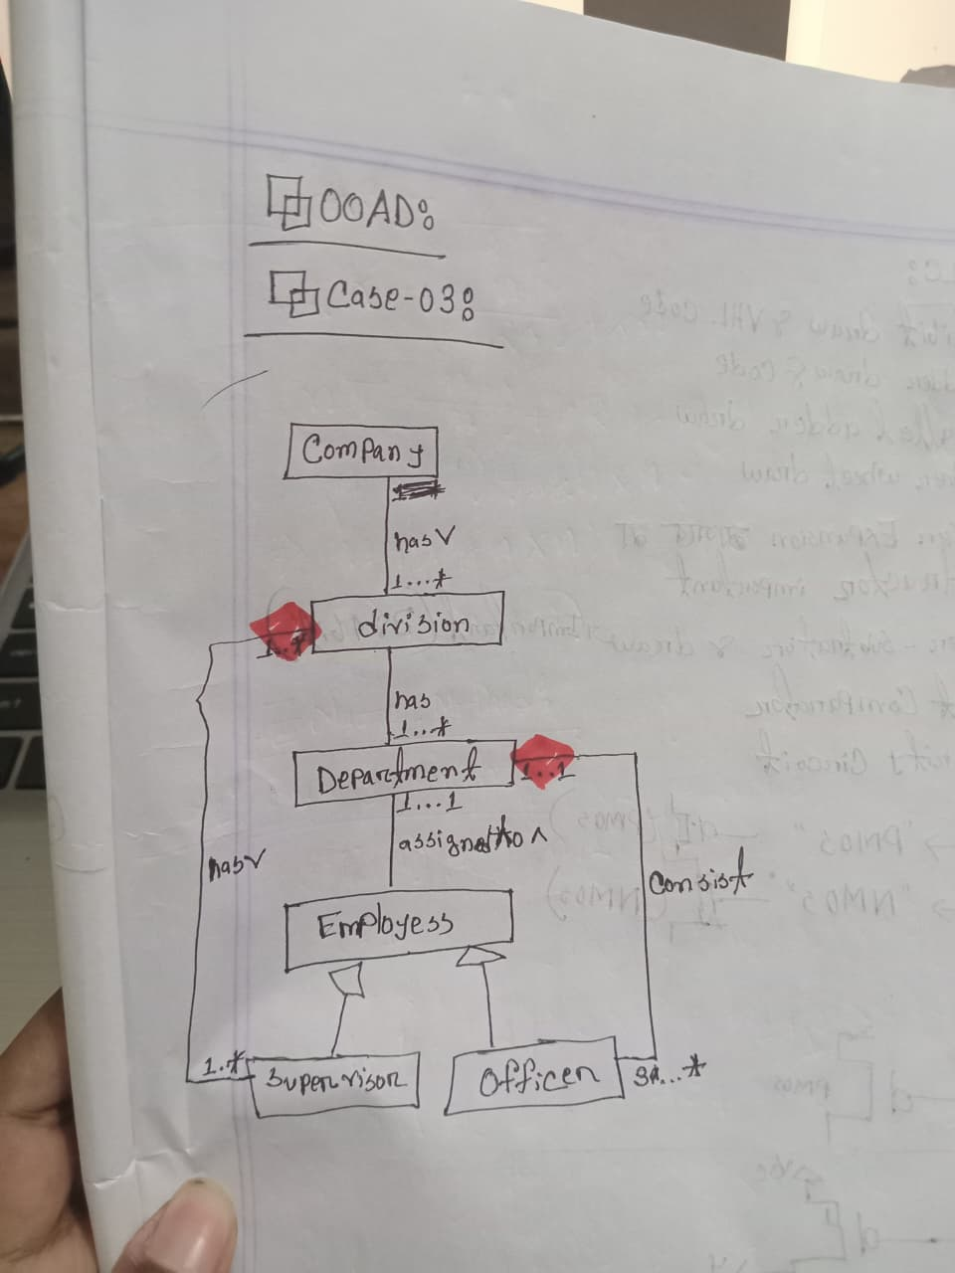

Case 4

The library contains books and journals. It may have several copies of a given book. Some of the books can be reserved for short-term loans and others for long-term. Member of library can borrow books. There is a special type of member- Member of Staff, who can borrow the journals. The system must keep track of when books and journals are borrowed.
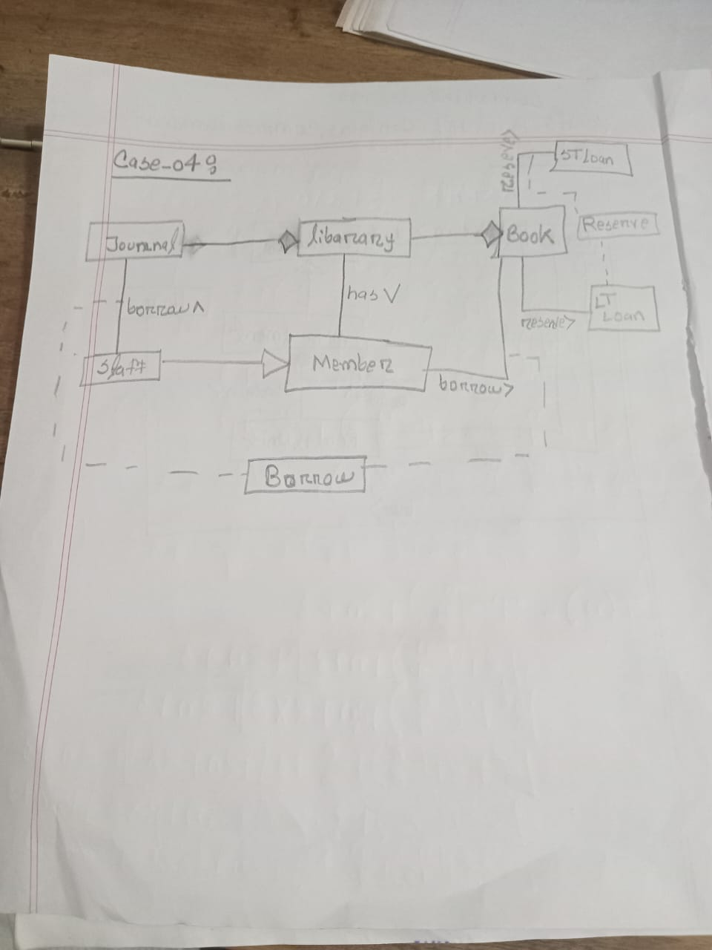

Case 5

A nonprofit organization depends on different types of persons for its successful operation. Three types of persons are of greatest interest: employees, volunteers, and donors. Employees and volunteers work on various projects organized by the organization. An employee is responsible for writing reports on the project at the completion of the project. A volunteer works under the supervision of an employee. One project consists of many sections. To become a recognized donor, a donor must have donated one or more items. An item may have no donors, or one or more donors. Projects and events are also sponsored by sponsors. Sometimes a single project or event is sponsored by multiple sponsors. An event consists of various activities.
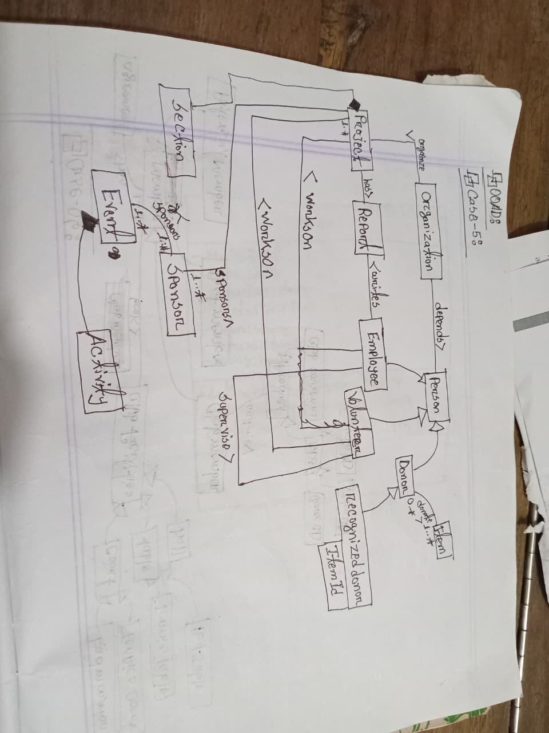

Case 6

A member can be of three types- potential member, past member and club member. Club members orders for products. Products can be club souvenirs or CDs. CDs can be audio CD, Video CD or Game CD. There is an agreement for each member. A single agreement can be made for more than one member, but all the members must sign the agreement. Members can book club facilities. Club facilities are courts, tables and halls. The courts are Badminton court and Tennis Court. The tables are for Tennis and Pool.
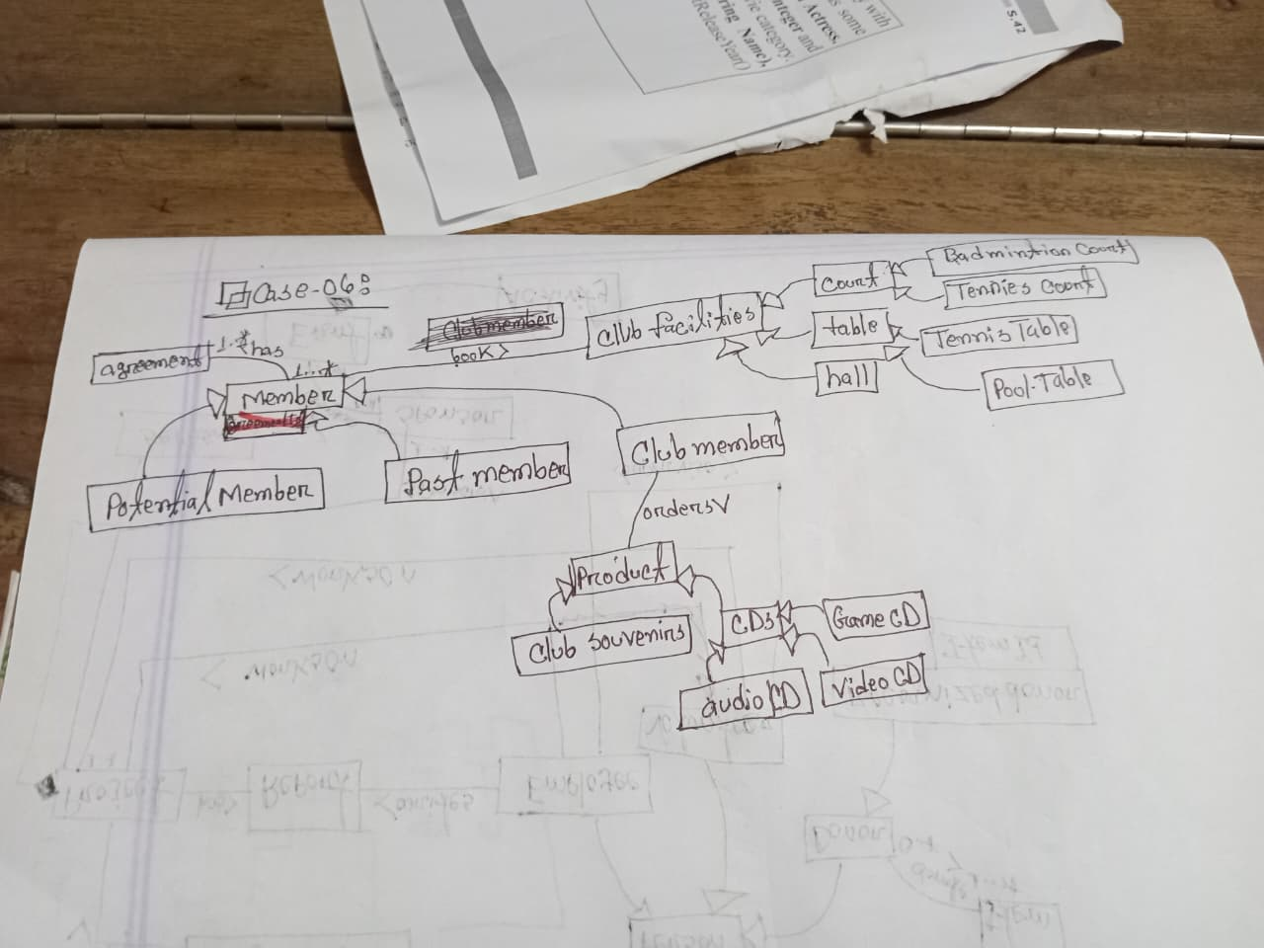

Class Notation Draw:

